**CST8215 – Lab 9 Submission**

Student Number: ______41019241______

Student Name: ______Adam Di Cioccio____________

Section Number: __321__ (e.g. 322, 323, 363)

Date: __November 16, 2020___

Procedure

Where you see *Provide screenshot here* you are being asked to take the screenshot from PG Admin (both the top pane where you have typed in the SQL statement and the bottom pane showing the results of the SQL statement)

Abstract

A small city library wants to store its inventory of books. The following information is kept manually by the Librarian. The library is asking to build a database to store this information as it is getting to be extremely hard to maintain.

**Author**

* An author writes at least one book.
* A book can be associated with only one author, the primary author of the book

**Publisher**

* A book title is published by only one publisher.
* A publisher publishes at least one book.
* The same book title cannot be published by more than one publisher

**Book**

* Book ID identifies the book and the book must have a Title

**Borrower**

* A borrower can borrow more than one book

**Library (Inventory)**

* The library maintains a copy number for each book of the same title.
* The same book title can be lent to more than one borrower.
* The library maintains a copy number for each book of the same title.
* Copy number begins with 1 for a title.
* Copy number increments by 1 for each copy of the same title.
* The copy number is reset for each title.
* It is possible that all copies of a book are in the library.
* It is possible that no copy of a book has been borrowed.
* A person is a borrower even if they have not borrowed a book; they may borrow in future.
* If borrower returns all borrowed books, they are still considered a borrower.
* A borrower’s historical data is not maintained.

Submission Requirements

1. Document the normalization details (layout as follows, showing each of the three phases (1st, 2nd and 3rd normal forms):

Entity 1 -- (col1, col2, col3)

Entity 2 – (col4, col5)

Entity 3 – (col6, col7, col8, col9)

*Separate WORD document (this is a text-based deliverable)*

**UNF**

Book ID, Book title, Author name, Publisher name, Borrower ID, Borrower name, Library transaction ID, Book copy number

**1NF**

*Book –* Book ID, Book title, Book copy number, Author name, Publisher name

*Library -* Borrower ID, Borrower name, Library transaction ID

**2NF**

*Book –* Book ID, Book title, Book copy number, Author name, Publisher name

*Borrower -* Borrower ID, Borrower name

*Borrowed book -* transaction ID

**3NF**

*Book –* Book ID, Book title

*Author –* Author name

*Publisher –* Publisher name

*Borrower -* Borrower ID, Borrower name

*Borrowed book -* transaction ID, book copy number

1. Screenshot of your data model in PG Modeler with the relationships created

*Provide screenshot here*

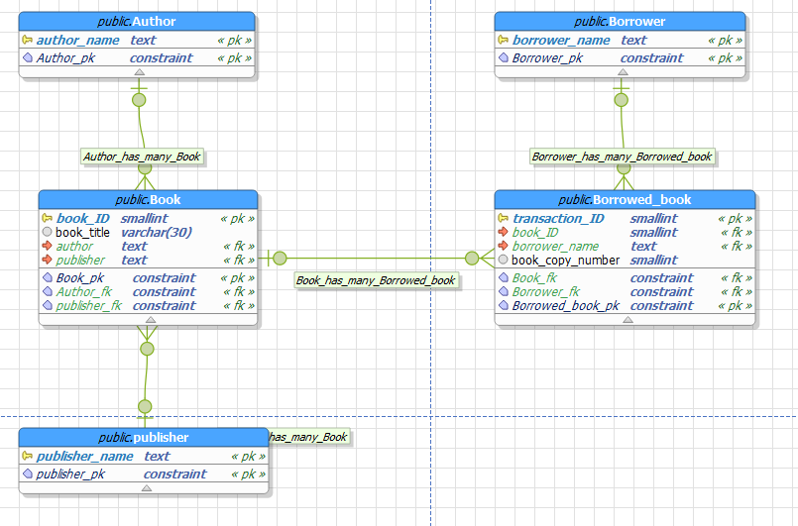

1. Select * from each of your new tables to show the data you inserted via your DML script

*Provide screenshot here*

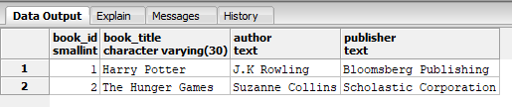

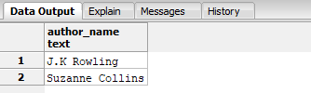

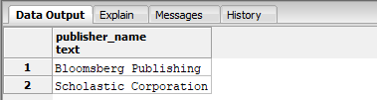

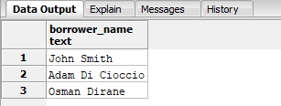

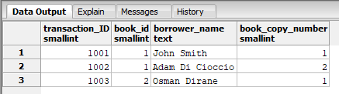

1. Screenshot of your JOIN ON statement which joins all your new tables together to produce a single result set.

*Provide screenshot here*

